New Study: Fasting May Regenerate the Entire Immune System
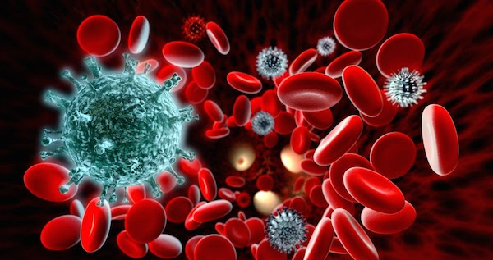
(Josh Paniagua – Massreport) Fasting has been done in spiritual and religious practices for millennia across the world by Christians, Buddhists, Muslims, Jews, Sikhs, and more. It is the act of consciously depriving oneself of food and/or drink for 24 hours or more.
Fasting has been used for deep meditation and spiritual healing in the past, but modern science is starting to recognize its potential health benefits.
A new study conducted at the University of Southern California suggests that not only can prolonged fasting help prevent immune system damage, but can produce hematopoietic stem cells which generates blood and cells in the immune system.
Periods of 2-4 days at a time over a 6-month period was found to destroy aged and damaged cells. Interestingly, this principle can theoretically be applied to cancer patients undergoing chemotherapy. For those of you who don’t know, chemotherapy kills cancer cells, but it also essentially destroys everything else in your body, including your immune system. And with this new information, fasting could potentially be an effective way to combat the side-effects of chemo.
Corresponding author, Edna M. Jones Professor of Gerontology and the Biological Sciences at the USC Davis School of Gerontology and director of the USC Longevity Institute, Valter Longo expressed his surprise saying, “We could not predict that prolonged fasting would have such a remarkable effect in promoting stem cell-based regeneration of the hematopoietic system.”
“When you starve, the system tries to save energy, and one of the things it can do to save energy is to recycle a lot of the immune cells that are not needed, especially those that may be damaged,” Longo says, “What we started noticing in both our human work and animal work is that the white blood cell count goes down with prolonged fasting. Then when you re-feed, the blood cells come back. So we started thinking, well, where does it come from?”
Many questions surrounding the effect of fasting are still waiting to be answered. Meanwhile, some experts are skeptical of the research.
Dr. Graham Rook, emeritus professor of immunology at University College London. “There is some interesting data here. It sees that fasting reduces the number and size of cells and then re-feeding at 72 hours saw a rebound. That could be potentially useful because that is not such a long time that it would be terribly harmful to someone with cancer. But I think the most sensible way forward would be to synthesize this effect with drugs. I am not sure fasting is the best idea. People are better eating on a regular basis.”
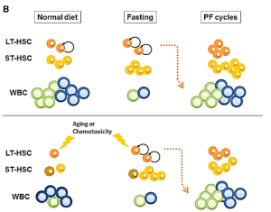
HSC = Hematopoietic Stem Cells ST = Short Term LT = Long Term WBC = White Blood
I’m not a doctor, but quite frankly, I’d had to disagree with Dr. Rook here. If the body is designed to naturally do something on its own, in this case regenerate itself through fasting, why in the hell would we waste millions of dollars trying to replicate that effect in a pill and then charge people out their ass just so they can afford it? Let’s see, thousands of dollars in insurance and ingesting synthetic drugs, or spending zero dollars and combating cell degeneration naturally?
Of course, I could be speaking way too soon, in fact I am, as definitive answers are still yet to emerge. Nonetheless, the data looks very promising.

